**Objectives**

1. Research information about software for a specific operating system (OS) environment. You will be assigned one of the operating systems form the list below. You will also be provided with a list of topics to investigate.
2. Organize your rough research information into a list of topics, sub-topics and facts. This process will involve identifying sub-topics, rearranging your rough research notes, and selecting (or highlighting) interesting facts.
3. Report a summary of your research in the form of a “concept map”. Use the PowerPoint template provided as a starting point. The concept map should only include the best and most interesting information from your organized research notes.
4. Your concept map can be created using: Smart Ideas, Prezi, PowerPoint or other similar applications.

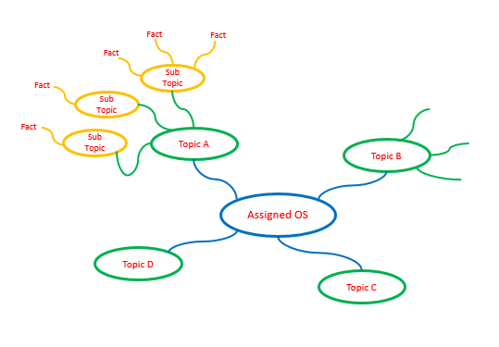

**Step 1 – Organized Research**

Research information about your assigned operating system (OS) environment.

* Guide your research according to the suggested topic list below
* Feel free to copy-and-paste as long as you keep track of your bibliographic references.
* Do not be too picky or concerned about formatting as you will organize this information later in step 2
* Select things that look interesting and don’t forget to include graphics images as well
* Upload your rough research notes to your repository when you are done.

Topic A – Application Software

Provide a summary of most important user application software targeted by this operating system and how it is similar to and deferent from standard PC software. Suggested sub-topics include:

* User (client) or network (server) applications
* Batch (run without user input) or interactive (user focused) processing
* Off-the-shelf (purchased) or custom developed applications
* Programming environment and languages supported

Topic B – Hardware

Provide a summary of the hardware targeted by this operating system and how it is similar to and deferent from standard PC hardware. Suggested sub-topics include:

* Speed of processors / memory
* Capacity of memory / attached disks
* Is it designed for home / office / corporate data center / industrial use
* Is it designed for client / server / network use

Topic C – User Interface

Provide a summary of the user interface and input devices targeted by this operating system and how it is similar to and deferent from a standard PC. Suggested sub-topics include:

* Does it support a windowed environment, command line, or network users
* Does it support multiple users at a time or single users
* Does it support multiple applications or a single application at a time
* Does it get rebooted (powered on / off) or is it always on

Topic D – Device Management

Provide a summary of the devices (disks, printers, etc.) and memory managed by this operating system and how it is similar to and deferent from a standard PC. Suggested sub-topics include:

* What types of disk drives and file systems does it support
* What type of input devices does it support
* What type of output devices does it support

Topic E – Security

Provide a summary of the security features provided by this operating system and how it is similar to and deferent from a standard PC. Suggested sub-topics include:

* What types of user accounts and user permissions does it support
* How does it protect against conflicts / interference between legitimate application processes
* How does it protect against malicious software
* How does it support software updates and security updates

Topic F – Network Connectivity

Provide a summary of the network connectivity provided by this operating system and how it is similar to and deferent from a standard PC. Suggested sub-topics include:

* Is the computer stand-alone or part of a larger network
* What type of network and internet connections does it provide
* Does it provide other services such as backup, firewall, etc.

**Step 2 – Concept Map**

Create a “concept map” as a final report of your organized research.

* Use the diagram in the introduction as a starting point.
* You should have six (6) first level topics from “Application Software”   
  to “Network Connectivity”
* Each first level topic should have at least three (3) sub-topics
* Each sub-topic should be supported by a number of facts / items of interest

Select the best and most interesting information from your organized research.

* Summarize and edit your information to fit on the concept map.

Upload your Research Notes and Concept Map to your GitHub Repository

* Your concept map can be created using: Smart Ideas, Prezi, PowerPoint or other   
  similar applications.
* Option1: Create and upload a PDF of your concept map
* Option2: Include a link to your Concept Map in your Student Questions
  + Make sure that your link is Sharable so Mr. Nestor can open your map

**Appendix A**

|  |  |  |
| --- | --- | --- |
| **Operating System** | **Student 1** | **Student 2** |
| Ubuntu  (Linux) |  |  |
| z/OS  (IBM) |  |  |
| Solaris  (Oracle) |  |  |
| HP-UX  (Hewlett Packard) |  |  |
| Windows NT  (Windows Server) |  |  |
| Red Hat Enterprise (IBM Summit) |  |  |
| QNX  (Blackberry) |  |  |
| VxWorks  (Wind River) |  |  |
| AOSP  (Android Alphabet) |  |  |
| Ubuntu  (Linux) |  |  |
| z/OS  (IBM) |  |  |
| Solaris  (Oracle) |  |  |
| HP-UX  (Hewlett Packard) |  |  |
| Windows NT  (Windows Server) |  |  |
| Red Hat Enterprise (IBM Summit) |  |  |
| QNX  (Blackberry) |  |  |
| VxWorks  (Wind River) |  |  |
| AOSP  (Android Alphabet) |  |  |
|  |  |  |
|  |  |  |
|  |  |  |
|  |  |  |